Geodesic Patterns for Free-form Architecture

MPDA’18 Master Thesis —— UPC-ETSAV

Alan Rynne Vidal

6 August 2018

Lorem ipsum dolor sit amet, consetetur sadipscing elitr, sed diam nonumy eirmod tempor invidunt ut labore et dolore magna aliquyam erat, sed diam voluptua. At vero eos et accusam et justo duo dolores et ea rebum. Stet clita kasd gubergren, no sea takimata sanctus est Lorem ipsum dolor sit amet. Lorem ipsum dolor sit amet, consetetur sadipscing elitr, sed diam nonumy eirmod tempor invidunt ut labore et dolore magna aliquyam erat, sed diam voluptua. At vero eos et accusam et justo duo dolores et ea rebum. Stet clita kasd gubergren, no sea takimata sanctus est Lorem ipsum dolor sit amet. Lorem ipsum dolor sit amet, consetetur sadipscing elitr, sed diam nonumy eirmod tempor invidunt ut labore et dolore magna aliquyam erat, sed diam voluptua. At vero eos et accusam et justo duo dolores et ea rebum. Stet clita kasd gubergren, no sea takimata sanctus est Lorem ipsum dolor sit amet.

Table of Contents

# Introduction

*You can download the latest PDF version* [***HERE***](https://alanrynne.github.io/MPDA_18-MasterThesis/output/Geodesic-Patterns.pdf) *And the latest DOCX version* [***HERE***](https://alanrynne.github.io/MPDA_18-MasterThesis/output/Geodesic-Patterns.docx)

This section explains the different algorithmic aproaches that can be taken in order to completely cover any given freeform surface with panels, ideally wood or metal, which are of approximately the same width and rectantular (or nearly rectangular) when flat and that achieve a surface paneling that is not only cost-effective but also watertight.

To be continued…

# Background

There is very little backgrounnd on this topic without entering direclty into Orlando’s topic Ruled Surfaces. Some background that must be included:

1. Burj Khalifa interior panelling (Meredith and Kotronis 2013)
2. Ghery’s architecture in general uses same width metal sheets to cover entire buildings, although I am not shure if that is not Orlando’s subject either…
3. Denis Shelden thesis on constructability of gherys architecture (Shelden 2002)
4. MAYBE?? Include non-optimized builidng examples to demonstrate the method’s usefulness.
5. Looking for other built examples or previous/further research on the subject.

# Computer programs using this technique

There are no programs that develop this technique “out of the box”, but it it based on simple algorithms and can be easily reproduced in any of the latest 3D modeling programs that allow any form of scripting (visual or otherwise) to generate and manipulate 3D geometries. Some examples of this might be:

1. Rhino + Grasshopper
2. Revit + Dynamo
3. Houdini
4. 3DMax

There also exist some powerful geometry processing libraries that can help with the task of computing geodesic curves, distances & fields (which are widely used in this chapter) and other libraries oriented to general scientific and mathematical computing, which are usefull when numerical optimization is needed during the process. Some of those libraries are:

1. [LibiGL](http://libigl.github.io/libigl/)(C++ with Python bindings)
2. [CGal](https://www.cgal.org/) (C++)
3. [OpenMesh](https://www.openmesh.org/) (C++ with Python bindings)
4. [NumPy](http://www.numpy.org) (Python Computing Library)
5. [SciPy](http://www.scipi.org) (Python Scientific Computing Library )

# Geodesic curves

In differential geometry, a *geodesic curve* is the generalization of a straight line into curved spaces (see fig. 1).

Also, in the presence of an *affine connection*, a geodesic is defined to be a curve whose tangent vectors remain parallel if they are transported along it. We will explore the notion of vector *parallel transport* in the following sections.

For triangle meshes, shortest polylines cross edges at ***equal angles***.

Finding the truly shortest geodesic paths requires the computation of distance fields (see Carmo 2016; Kimmel and Sethian 1998)



Figure 1: If an insect is placed on a surface and continually walks “forward”, by definition it will trace out a geodesic (image taken from [Wikipedia](https://en.wikipedia.org/wiki/Geodesic)).

## Algorithmic ways of generating geodesics

The computation of geodesics on smooth surfaces is aclassical topic, and can be reduced to two different solutions, depending on the initial conditions of the problem, you can basically find two tipes of problems (Deng 2011):

Initial value problem

given a point $p∈S$ and a vector $v∈T_{p}S$, find a geodesic which is incident with $p$, such that the tangent vector fo $g$ at $p$ is $v$.

Boundary value problem

given two points $p_{1},p_{2}∈S$ find a geodesic $g$ connecting $p_{1}$ and $p_{2}$.

Both problems have different ways of being solved either numerically, graphically or by the means of simulations. The initial value problem can be solved using the concept of *straightest geodesics* (Polthier and Schmies 1998), whereas the boundary value problem has a very close relation with the computation of *shortest paths* between two points on a surface.

It is important to note that, during this chapter, all surfaces are discretized as triangular meshes (V,E,F) of sufficient precision.  
**What would that precision be?? %?? distance to reference surf??**

# Developable surfaces

This is very well explained in p.170 of Denis Shelden thesis (Gerard’s suggestion). Explanation is inspired by that section.

It is also important to introduce the concept of the *developable surface*, a special kind of surface that have substantial and variable normal curvature while guaranteeing zero gaussian curvature, and as such, this surfaces can be *unrolled* into a flat plane with no deformation of the surface. This surfaces have been an extremely important design element in the practice of known architect Frank Ghery and explained in (Shelden 2002).

# Geodesic patterns

What are geodesic patterns?

* Patterns made of panels (wood or metal).
* Bent by their weak axis.
* Mounted on a free-form surface.
* Rectangular or cuasi-rectangular when layed flat.
* Water-tight.
* Overall shape is achieved by pure bending. See Fig. 2



Figure 2: Geodesic pattern examples & previous work

## Properties to aim for in panels

### Geodesic property

* Long Thin panels that bend about their weak axis
* Zero geodesic curvature
* Represent the shortest path between two points on a surface

### Constant width property

* Panels whose original, unfolded shape is a rectangle.
* The only way this can happen is if the entire surface is developable.
* For all other surfaces:
  + Assuming no gaps between panels
  + Panels will not be exactly rectangular when unfolded
  + ***Requirement:*** Geodesic curves that guide the panels must have approximately constant distance from thier neighbourhood curves.

### Developable (or ‘pure-bending’) property

* Bending panels on surfaces changes the distances in points only by a small amount so,
* A certain amount of twiting is also present in this aplications.  
  ***Some methods in this chapter do not take into account this property.***

## Problem Statement

Problem 1

Look for a system of geodesic curves that covers a freeform surface in a way that:

1. They have approximate constant distance with it’s neighbours.
2. This curves will serve as guiding curves for the panels.
3. The panels are to cover the surface with ***no overlap*** and ***only small gaps***

Problem 2

Look for a system of geodesic curves in a freeform surface which:

1. Serve as the boundaries of wooden panels.
2. The panel’s deveopment is ***nearly straight***.
3. Those panels cover the surface with ***no gaps***

# Design strategies for geodesic systems

## Design by parallel transport

This method, described in (Pottmann et al. 2010), allows for the generation of a system of geodesic curves where either the maximum distance or the minimum distance between adjacent points ocurrs at a prescribed location.

In differential geometry, the concept of *parallel transport* (see fig. 3) of a vector ***V*** along a curve ***S*** contained in a surface means moving that vector along ***S*** such that:

1. It remains tangent to the surface
2. It changes as little as possible in direction
3. It is a known fact that the length of the vector remains unchanged

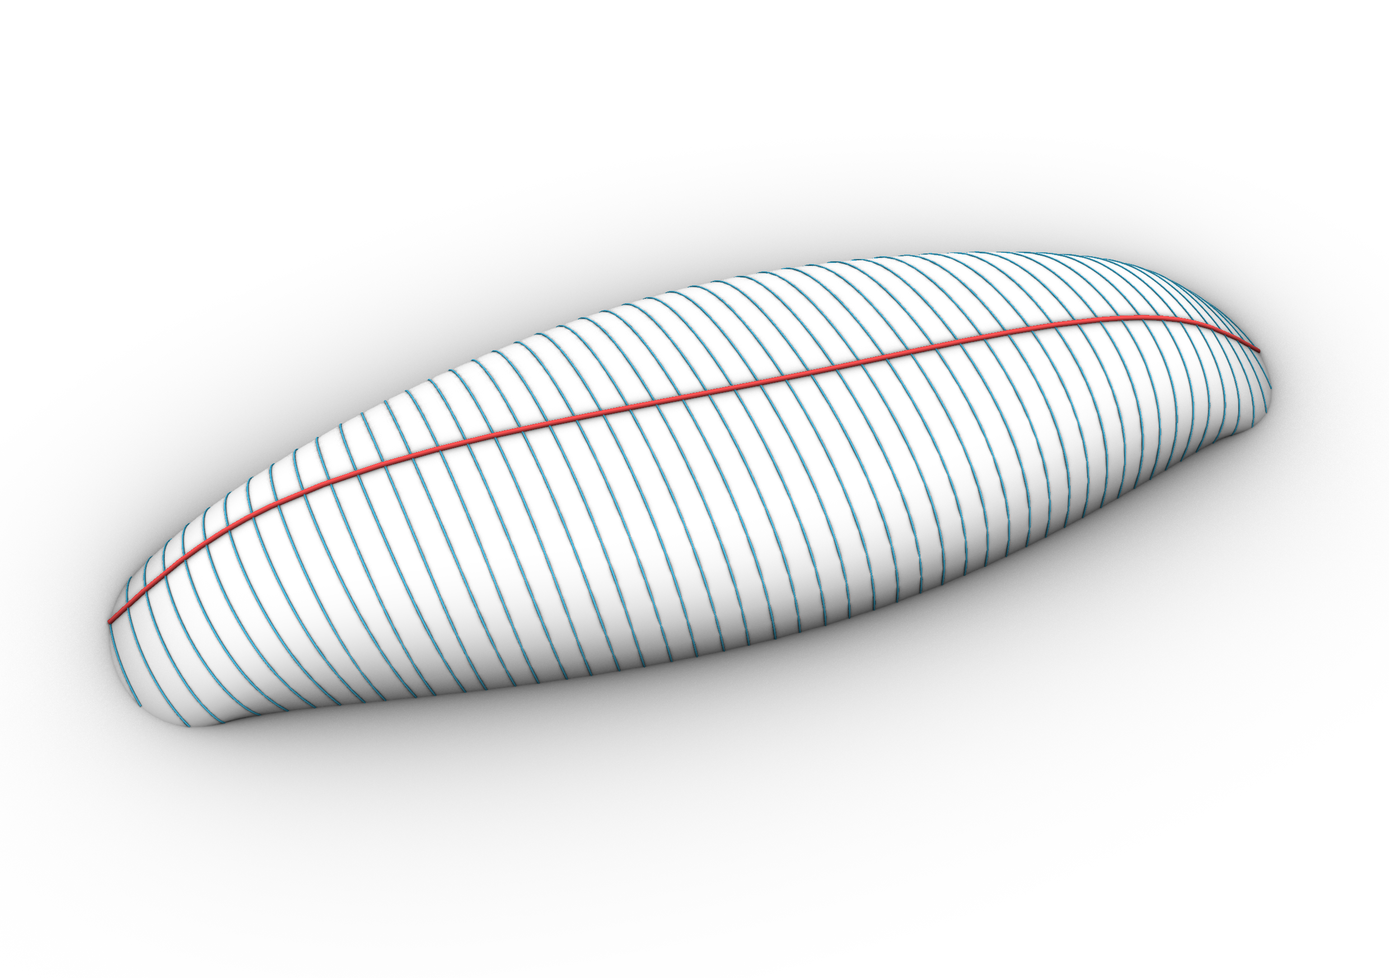

Figure 3: Example of parallel transport method. Generatrix geodesic $g$ (red) and geodesics $g^{⊥}$ generated from a parallel transported vector (blue) computed given a point and a vector $v$ tangent to the surface, in both positive and negative directions.



Figure 4: Parallel transport along a curve $g$ lying on surface $S$ is equivalent to projecting $v_{i−1}$ onto the tangent plane on $p_{i}$ and subsequently normalizing $v_{i}$.

### Procedure

Following this procedure, *extremal distances between adjacent geodesics occur near the chosen curve.* Meaning:

1. For surfaces of **positive curvature**, the parallel transport method will yield a 1-geodesic pattern on which the *maximum distance* between curves will be $W$.
2. On the other hand, for surfaces of **negative curvature**, the method will yield a 1-geodesic pattern with $W$ being the *closest (or minimum)* distance between them.

The placement of the first geodesic curve and the selection of the initial vector are not trivial tasks. For surfaces with high variations of surfaces, the results might be unpredictable and, as such, this method is only suitable for surfaces with nearly constant curvature. Other solutions might involve cutting the surface into patches of nearly-constant curvature, and applying the *parallel transport method* independently on each patch.

## Design by evolution & segmentation

Two main concepts are covered in this section, both proposed by (Pottmann et al. 2010): the first, what is called the *evolution method*, and a second method based on *piecewise-geodesic* vector fields.

### The *evolution method*

As depicted in: Starting from a source geodesic somewhere in the surface:

* Evolve a pattern of geodesics iteratively computing ‘next’ geodesics.
* ‘Next’ geodesics must fullfil the condition of being at approximately constant distance from its predecesor.
* If the deviation from its predecesor is too great, breakpoints are introduced and continued as a *‘piecewise geodesic’.*
* ‘Next geodesics’ are computed using Jacobi Fields

### Distances between geodesics

1. No straight forward solution.
   1. Only for rotational surfaces (surfaces with evenly distriuted meridian curves).
2. **But** a first-order aproximation of this distance can be approximated:

Starting at time $t=0$ with a geodesic curve $g(s)$, parametrized by arc-length $s$, and let it move within the surface.  
A snapshot at time $t=ε$ yields a geodesic $g^{+}$ near $g$.

$$g^{+}(s)=g(s)+εv(s)+ε^{2}(…) (1)$$

The derivative vector field $v$ is called a *Jacobi field*. We may asume it is orthogonal to $g(s)$ and it is expressed in terms of the geodesic tangent vector $g′$ as:

$$v(s)=w(s)⋅R_{π/2}(g′(s)), where w″+Kw=0 (2)$$

Since the distance between infinitesimally close geodesics are governed by Eq. 2, that equation also goberns the width of a strip bounded by two geodesics at a small finite distance.

Using this principle, you can develop strips whose width $w(s)$ fulfills the Jacobi equation [1] for some value $K<0$.  
Gluing them together will result in a surface of approximate Gaussian curvature.

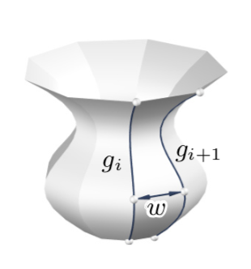 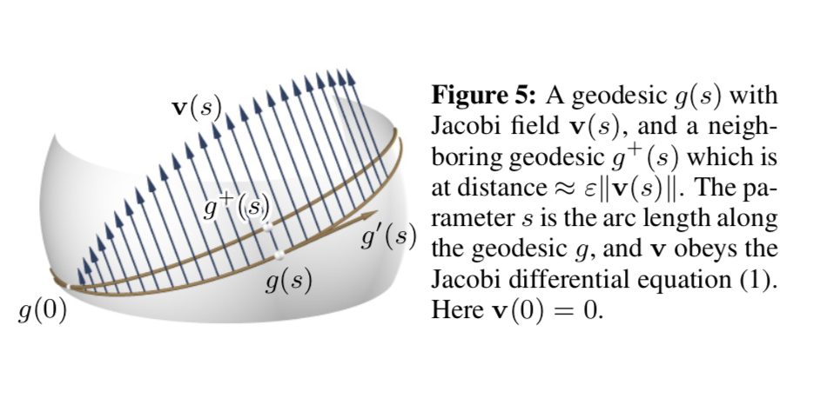

Figure 5: Geodesic distances on sphere. a — Distances between geodesics, b — Distances between geodesics

### Obtaining the ‘next’ geodesic

Input:

A freeform surface $S$, a desired width $W$ and a starting geodesic curve $g_{0}$

Output:

The ‘next’ computed geodesic on $S$

Pseudocode:

Given a valid $S$, $W$ and $g_{0}$:

1. Sample the curve $g_{0}$ at uniformly distritbuted arc-length parameters $x_{i}$.
2. Compute a a set of geodesics $h_{i}⊥g_{0}$ startingt points $p(x_{i})$ on $g_{0}$.
3. Select a width function $ω(s)$ that is closest to a desired target width function $W(s)$ (Width function can return a fixed value or a computed value using curvature. It could be further improved accomodate other measures).
4. Select a Jacobi field $v(s)$ using $ω(s)$ as stated in Eq. 2.
5. ‘Walk’ the lengh of the vector $v(s)$ on $h_{i}$ to obtain $χ_{i}$. These points approximate position of the *next geodesic* "g^+_i".
6. The previous step can have a very big error margin, therefore we must compute $g_{i}^{+}$:
   1. Select a point $χ_{i}$ and name it $χ_{0}$.
   2. We can compute the next geodesic by minimizing the error between the width function $ω(s)$ and the *signed distance* of the computed $g_{i}^{+}$ to $g_{0}$.
7. Return computed geodesic $g_{i}^{+}$

Any given surface can be completely covered in this maner by recursivly computing the next geodesic using the previous, given some margin of error.

 

Figure 6: Surface covered by a 1-geodesic pattern using the evolution method. Fig. 6 (a) shows ***normal*** implementation; while fig. 6 (b) implements the piece-wise geodesic concept. Both images use the same parameters.

## Piecewise-geodesic vectorfields

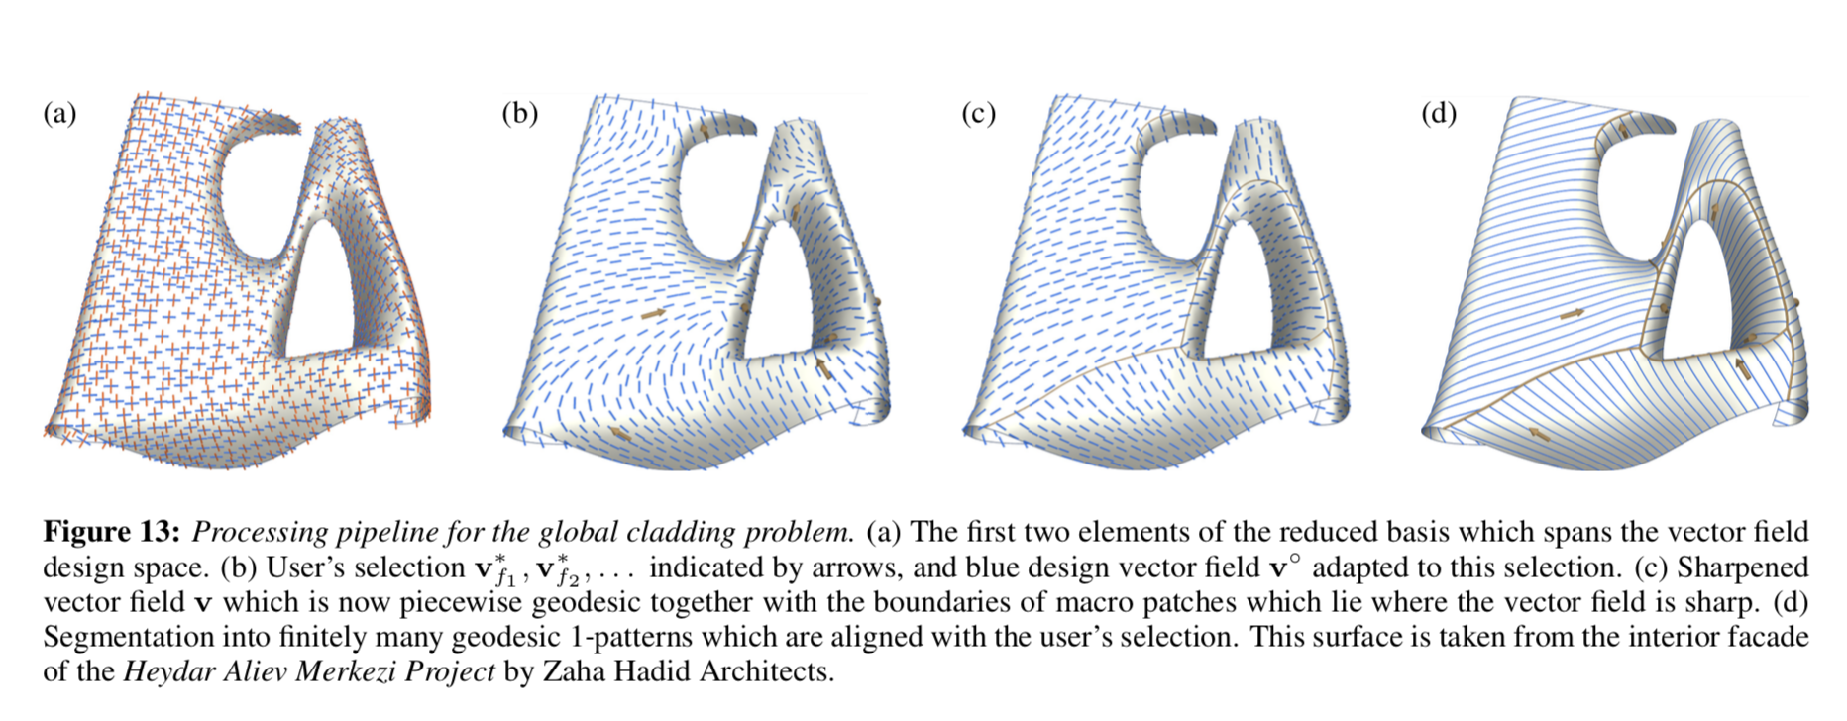

Figure 7: Geodesic Vector Fields

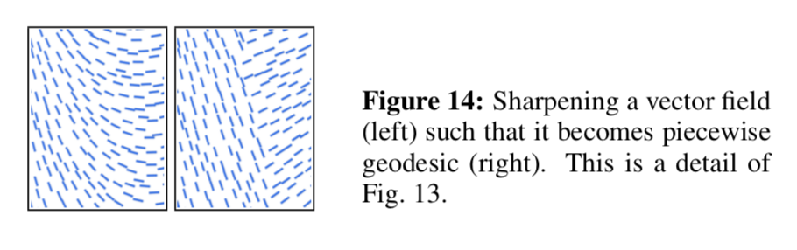

Figure 8: Geodesic Vector Field sharpening

# Panels from curve patterns

In this section, we will discuss several ways to generate panels from a system of 1-geodesic curves.

## Tangent-developable method

The notion of ***Conjugate tangents*** on smooth surfaces must be defined:

* Strictly related to the ***Dupin Indicatrix***
* In negatively curved areas, the Dupin Indicatrix is an hyperbola whose asymptotic directions (A1, A2)
* Any parallelogram tangentialy circumscribed to the indicatrix defines two conjugate tangents **T** and **U**.
* The asymptotic directions of the dupin indicatrix are the diagonals of any such parallelogram.



Tangent developable method for panels

Initial algorithm is as follows:

For all geodesics $s_{i}$ in a given pattern:

1. Compute the *tangent developable surfaces $→Ψ_{i}$*
2. Trim $Ψ_{i}$ along the intersection curves with their respective neighbours.
3. Unfold the trimed $Ψ_{i}$, obtaining the panels in flat state.

***Unfortunately***, this method needs to be refined in order to work in practice because:

1. The rulings of tangent developables may behave in weird ways
2. The intersection of the neighbouring $Ψ_{i}$’s is often *ill-defined*.

Therefore, the procedure was modified in the following way:

1. Compute the *tangent developable surfaces $Ψ_{i}$* for all surfaces $s_{i}→i=even numbers$
2. Delete all rulings where the angle enclose with the tangent $α$ is smaller than a certain threshold (i.e. 20º).
3. Fill the holes in the rulings by interpolation (???)
4. On each ruling:
   1. Determine points $A_{i}(x)$ and $B_{i}(x)$ which are the closest to geodesics $s_{i−1}$ and $s_{i+1}$. This serves for trimming the surface $Ψ_{i}$.
5. Optimize globaly the positions of points $A_{i}(x)$ and $B_{i}(x)$ such that
   1. Trim curves are *smooth*
   2. $A_{i}(x)$ and $B_{i}(x)$ are close to geodesics $s_{i−1}$ and $s_{i+1}$
   3. The ruling segments $A_{i}(x)B_{i}(x)$ lies close to the *original surface $Φ$*



Figure 9: Tangent developable method examples

## The Bi-Normal Method

The second method for defining panels, once an appropriate system of geodesics has been found on $Φ$, works directly with the geodesic curves.

Assume that a point $P(t)$ traverses a geodesic $s$ with unit speed, where $t$ is the time parameter. For each time $t$ there is:

* a velocity vector $T(t)$
* the normal vector $N(t)$
* a third vector $B(t)$, *the binormal vector*

This makes $T.N.B$ a ***moving orthogonal right-handed frame***

The surface $Φ$ is represented as a triangle mesh and $s$ is given as a polyline. For each geodesic, the associated surface is constructed according to Fig. 10. Points $L(t)$ and $R(t)$ represent the border of the panel, whose distance from $P(t)$ is half the panel width.



Figure 10: Binormal Method for panels & T.N.B. frame

## Method Comparison

See XXX for more info…

# Stress and strain in panels

The following section investigates the behaviour of a rectangular strip of elastic material when it is bent to the shape of a ruled surface $Ψ$ un such way that:

The central line $m$ of the strip follows the *‘middle geodesic’ $s$* in $Ψ$

This applies to both methods defining panels.fig. 11



Figure 11: Stress in panels

## Stress formulas

$$ρ=1/\sqrt{K}, (3)$$ $$d/2ρ≤C, with C=\sqrt{σ_{max}/E}, (4)$$ $$ε=\frac{1}{2}(d/2ρ)^{2}+⋯ (5)$$

### MISSING MORE INFO ON STRESS ANALYISIS**

# Final analysis cost, quality

All strategies must be compared against cost & quality of the different solutions.



Figure 12: Cost/Quality Final Assesment

## Frequent measures used in the topic

* Bounding-box diagonal of the panels

## Cost variables

Cost should be defined as:

1. ???
2. ???
3. ???

## Quality variables

Quality should be defined as:

1. ???
2. ???
3. ???

## Variable weighting method

Explanation of the weighting of variables?

# References

## Must include as bibtex references

* [Geodesic Lines Grasshopper implementation](https://www.grasshopper3d.com/forum/topics/geodesic-distance-from-points-on-mesh)
* [Non-optimized geodesic planks building](http://www.architectmagazine.com/technology/detail/la-cigarra-cafe-entry-pavilion_o)
* [Non-optimized geodesic planks stairwell](https://www.frameweb.com/news/cun-design-bridges-tradition-modernity-with-bamboo)
* [Discrete Geodesic Nets for Modeling Developable Surfaces](https://www.youtube.com/watch?v=rd5mg6VsfnA)
* [Video](https://vimeo.com/273000923)
* Add this paper to bib: [Discrete Geodesic Nets](https://arxiv.org/pdf/1707.08360.pdf)

## Main refs

Arsan, Güler Gürpinar, and Abdülkadir Özdeger. 2015. “Bianchi Surfaces Whose Asymptotic Lines Are Geodesic Parallels.” *Adv. Geom.* 15 (1). <https://doi.org/10.1515/advgeom-2014-0020>.

Carmo, Manfredo P do. 2016. *Differential Geometry of Curves and Surfaces: Revised and Updated Second Edition*. Courier Dover Publications.

Chen, Jindong, and Yijie Han. 1996. “Shortest Paths on a Polyhedron, Part I: Computing Shortest Paths.” *Int. J. Comput. Geom. Appl.* 06 (02). <https://doi.org/10.1142/s0218195996000095>.

Deng, Bailin. 2011. “Special Curve Patterns for Freeform Architecture.” Edited by Helmut Pottmanm and Niloy J. Mitra. <http://resolver.obvsg.at/urn:nbn:at:at-ubtuw:1-40363>.

Deng, Bailin, Helmut Pottmann, and Wallner Johannes. n.d. “Functional Webs for Freeform Architecture.” *Computer Graphics Forum* 30 (5): 1369–78. doi:[10.1111/j.1467-8659.2011.02011.x](https://doi.org/10.1111/j.1467-8659.2011.02011.x).

Eigensatz, Michael, Martin Kilian, Alexander Schiftner, Niloy J Mitra, Helmut Pottmann, and Mark Pauly. 2010. “Paneling Architectural Freeform Surfaces.” *ACM Transactions on Graphics (TOG)*. doi:[10.1145/1833349.1778782](https://doi.org/10.1145/1833349.1778782).

Jia, Yan-Bin. 2017. “Curves on a Surface.”

Kahlert, Joe, Matt Olson, and Hao Zhang. 2010. “Width-Bounded Geodesic Strips for Surface Tiling.” *Vis. Comput.* 27 (1). <https://doi.org/10.1007/s00371-010-0513-3>.

Kensek, Karen, Judith Leuppi, and Douglas Noble. 2000. “Plank Lines of Ribbed Timber Shell Structures.” In *Proceedings of the 22nd Annual Conference of the Association for Computer-Aided Design in Architecture, Acadia 2000: Eternity, Infinity and Virtuality in Architecture*, 261–66.

Kimmel, R, and J A Sethian. 1998. “Computing Geodesic Paths on Manifolds.” *Proc. Natl. Acad. Sci. U. S. A.* 95 (15). <https://doi.org/10.1073/pnas.95.15.8431>.

Meredith, Neil, and James Kotronis. 2013. “Self-Detailing and Self-Documenting Systems for Wood Fabrication: The Burj Khalifa.” In *Advances in Architectural Geometry 2012*, edited by Lars Hesselgren, Shrikant Sharma, Johannes Wallner, Niccolo Baldassini, Philippe Bompas, and Jacques Raynaud, 185–98. Vienna: Springer Vienna. <https://doi.org/10.1007/978-3-7091-1251-9_14>.

Polthier, Konrad, and Markus Schmies. 1998. “Straightest Geodesics on Polyhedral Surfaces.” In *Mathematical Visualization*, 135–50. <https://doi.org/10.1145/1185657.1185664>.

Pottmann, Helmut. 2010. “Architectural Geometry as Design Knowledge.” *Architectural Design* 80 (4). Wiley Online Library: 72–77. <https://doi.org/10.1002/ad.1109>.

Pottmann, Helmut, Michael Eigensatz, Amir Vaxman, and Johannes Wallner. 2015. “Architectural Geometry.” *Computers and Graphics* 47: 145–64. doi:[10.1016/j.cag.2014.11.002](https://doi.org/10.1016/j.cag.2014.11.002).

Pottmann, Helmut, Qixing Huang, Bailin Deng, Alexander Schiftner, Martin Kilian, Leonidas Guibas, and Johannes Wallner. 2010. “Geodesic Patterns.” In *ACM SIGGRAPH 2010 Papers on - SIGGRAPH ’10*. [https://doi.org/10.1145/1833349.1778780]( https://doi.org/10.1145/1833349.1778780).

Pottmann, Helmut, Alexander Schiftner, and Johannes Wallner. 2008. “Geometry of Architectural Freeform Structures.” In *Symposium on Solid and Physical Modeling*, 9. <https://doi.org/10.1145/1364901.1364903>.

Rose, Kenneth, Alla Sheffer, Jamie Wither, Marie-Paule Cani, and Boris Thibert. 2007. “Developable Surfaces from Arbitrary Sketched Boundaries.” In *SGP ’07 - 5th Eurographics Symposium on Geometry Processing*, edited by Alexander G. Belyaev and Michael Garland. SGP ’07 Proceedings of the Fifth Eurographics Symposium on Geometry Processing. Eurographics Association. <http://dl.acm.org/citation.cfm?id=1281991.1282014>.

Shelden, Dennis Robert. 2002. “Digital Surface Representation and the Constructibility of Gehry’s Architecture.” PhD thesis, Massachusetts Institute of Technology. <http://hdl.handle.net/1721.1/16899>.

Surazhsky, Vitaly, Tatiana Surazhsky, Danil Kirsanov, Steven J Gortler, and Hugues Hoppe. 2005. “Fast Exact and Approximate Geodesics on Meshes.” *ACM Trans. Graph.* 24 (3). <https://doi.org/10.1145/1186822.1073228>.

Wallner, Johannes, Alexander Schiftner, Martin Kilian, Simon Flöry, Mathias Höbinger, Bailin Deng, Qixing Huang, and Helmut Pottmann. 2010. “Tiling Freeform Shapes with Straight Panels: Algorithmic Methods.” In *Advances in Architectural Geometry 2010*, edited by Cristiano Ceccato, Lars Hesselgren, Mark Pauly, Helmut Pottmann, and Johannes Wallner. Vienna: Springer Vienna. <https://doi.org/10.1007/978-3-7091-0309-8_5>.

Weinand, Yves, and Claudio Pirazzi. 2006. “Geodesic Lines on Free-Form Surfaces - Optimized Grids for Timber Rib Shells.” *World Conference in Timber Engineering WCTE*. <https://infoscience.epfl.ch/record/118623>.

1. **Question:** What is $α$ in this formula? Missing image